1. **Agenda**:
   1. Various states of an entity during its life cycle with an example.
2. 
3. **Transient State**:  
   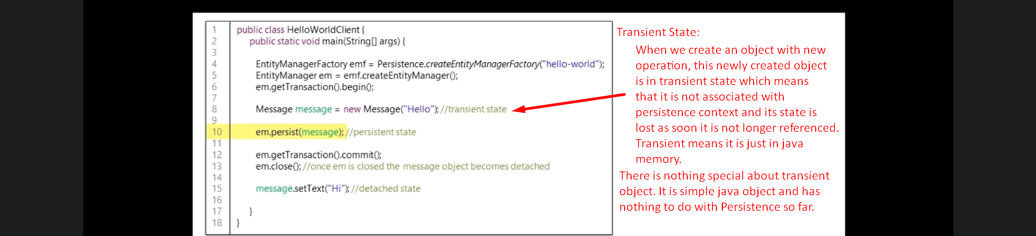 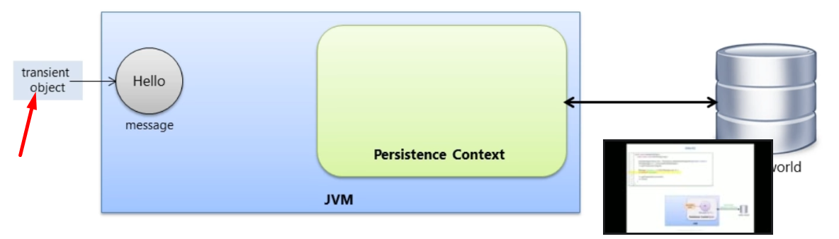
4. **Persistence State**:
   1. A persistence object is an object which has a Database Identity associated to it when we call entityManager.save(entityObject);
   2. The object has primary key value set as its DB identifier.

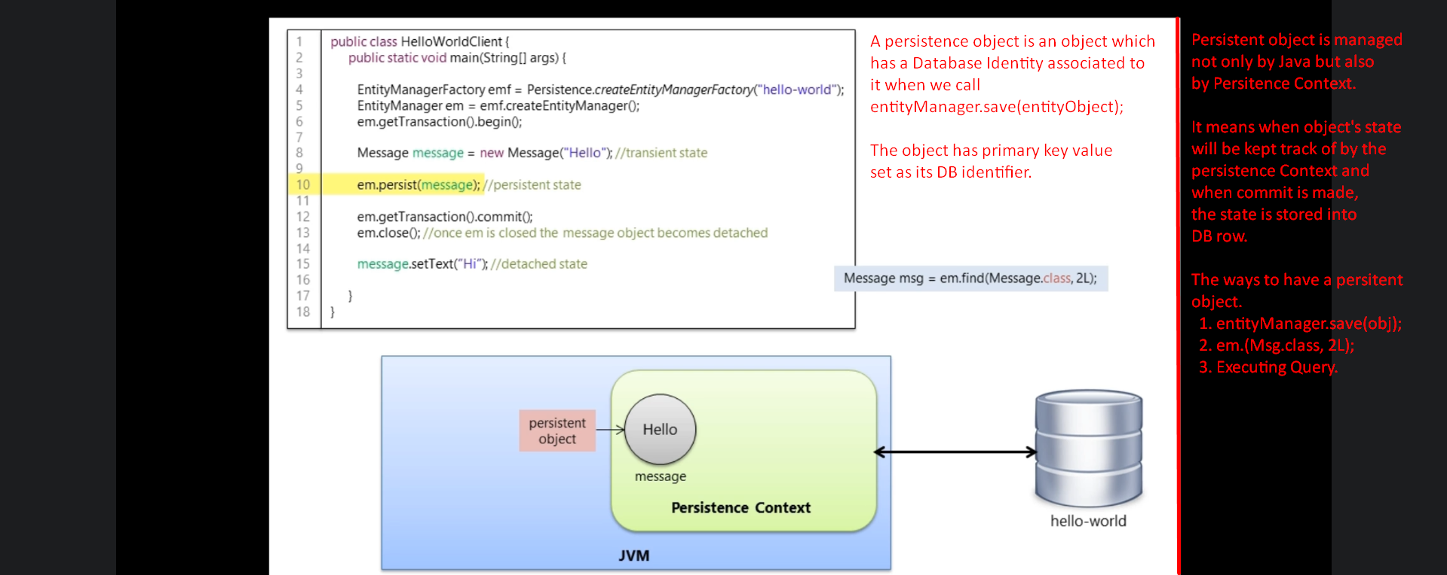

1. What is Persistence Context?
   1. It is first level cache.
   2. It has its own non-shared database connection.
   3. It does automatic dirty checking which means when transaction is committed, as it keeps track of data changes of a persistent object, it will save them into DB.  
      We will go into details in “Object Manipulation”.

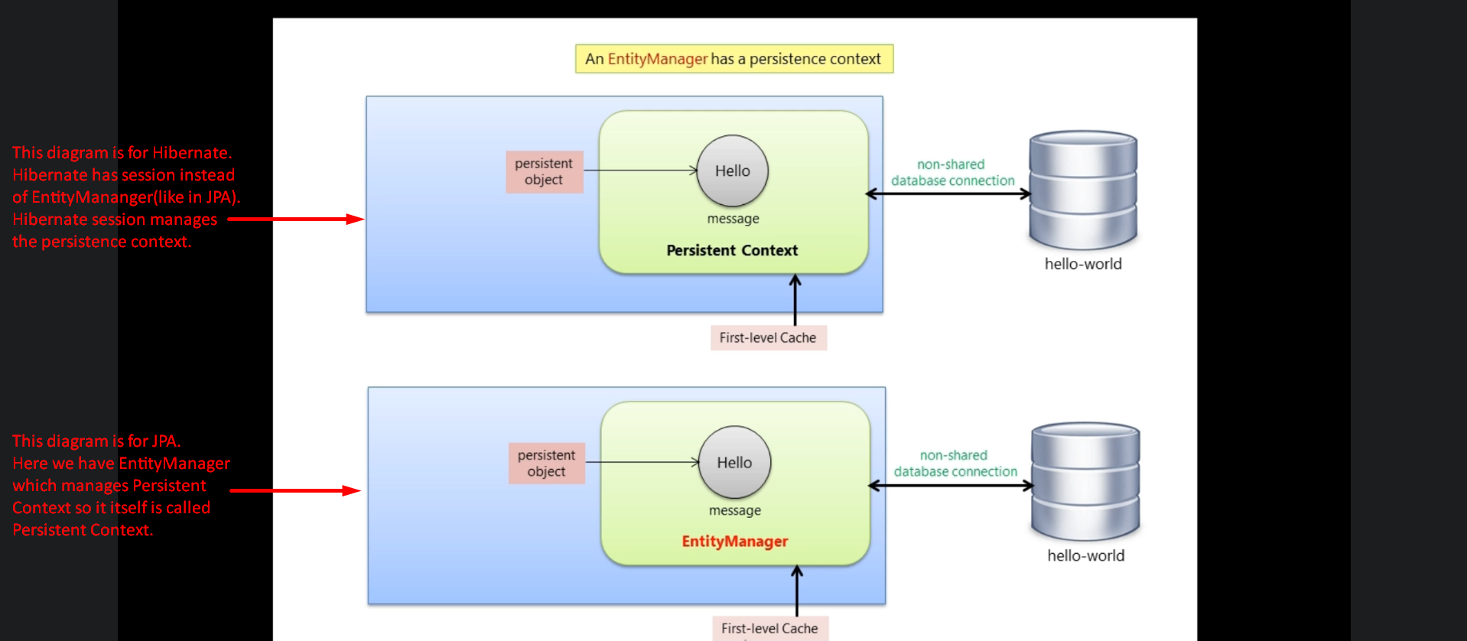**NOTE**: Whenever we create hibernate sessions or EntityManager within JPA, it internally creates Persistence Context.

1. 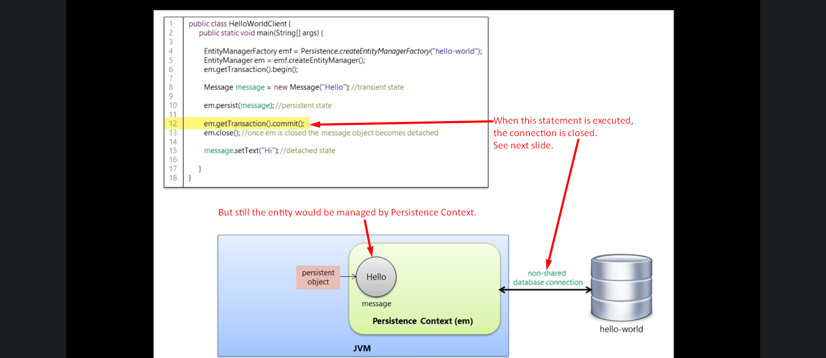
2. When commit is made, Auto Dirty Checking is performed means object’s modified state is flushed into DB as connection is going to be closed.
3. 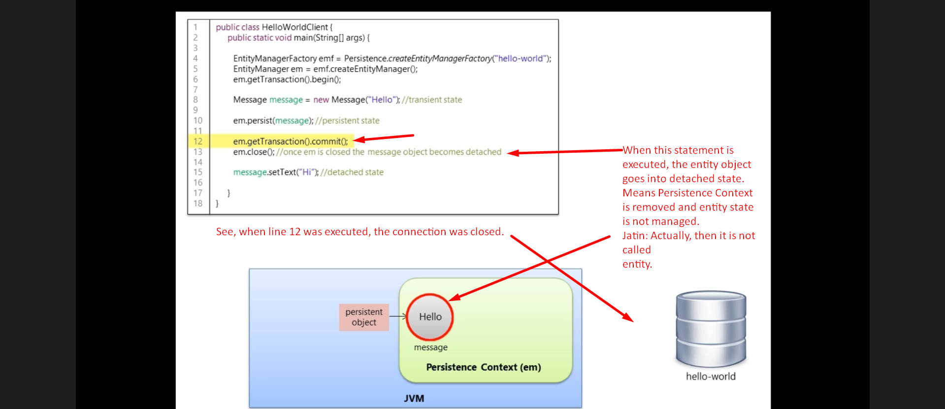
4. 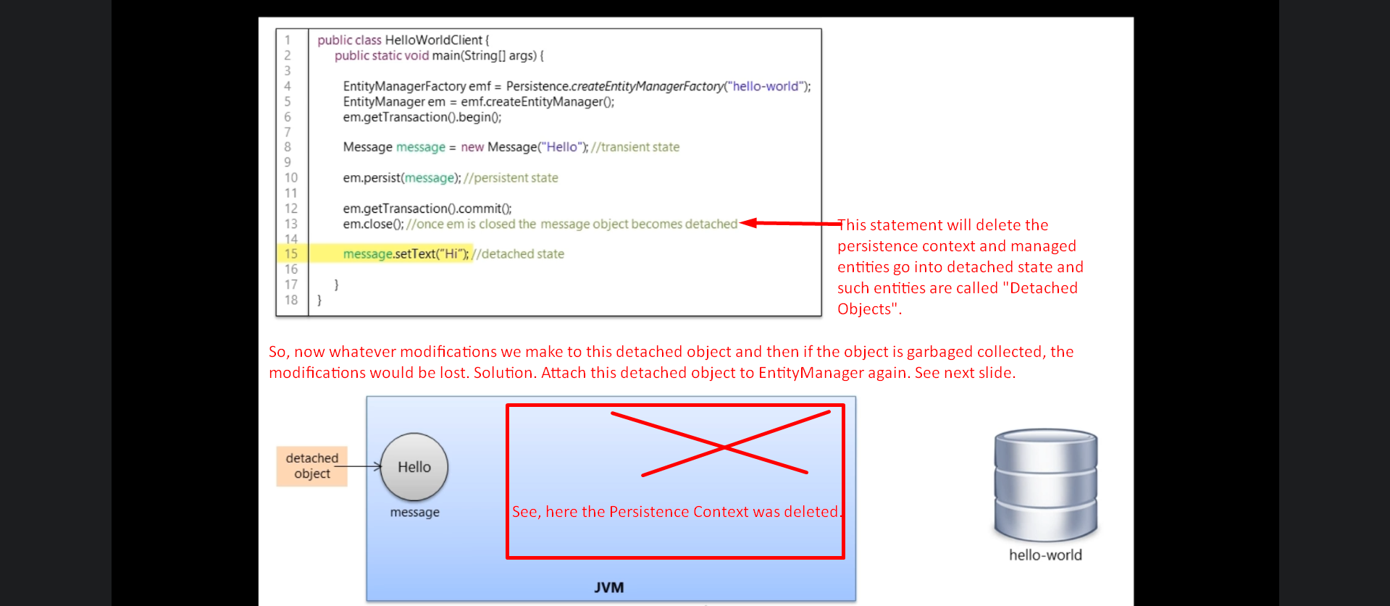
5. Merging a detached Object:  
   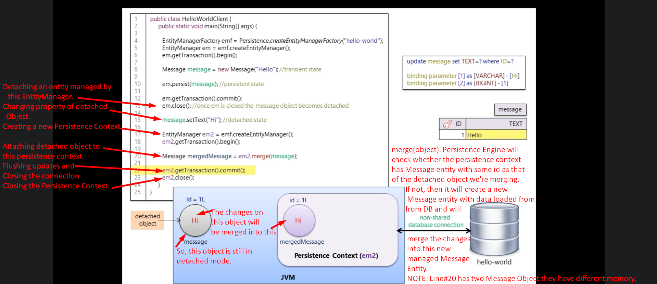
6. EntityManager.detach():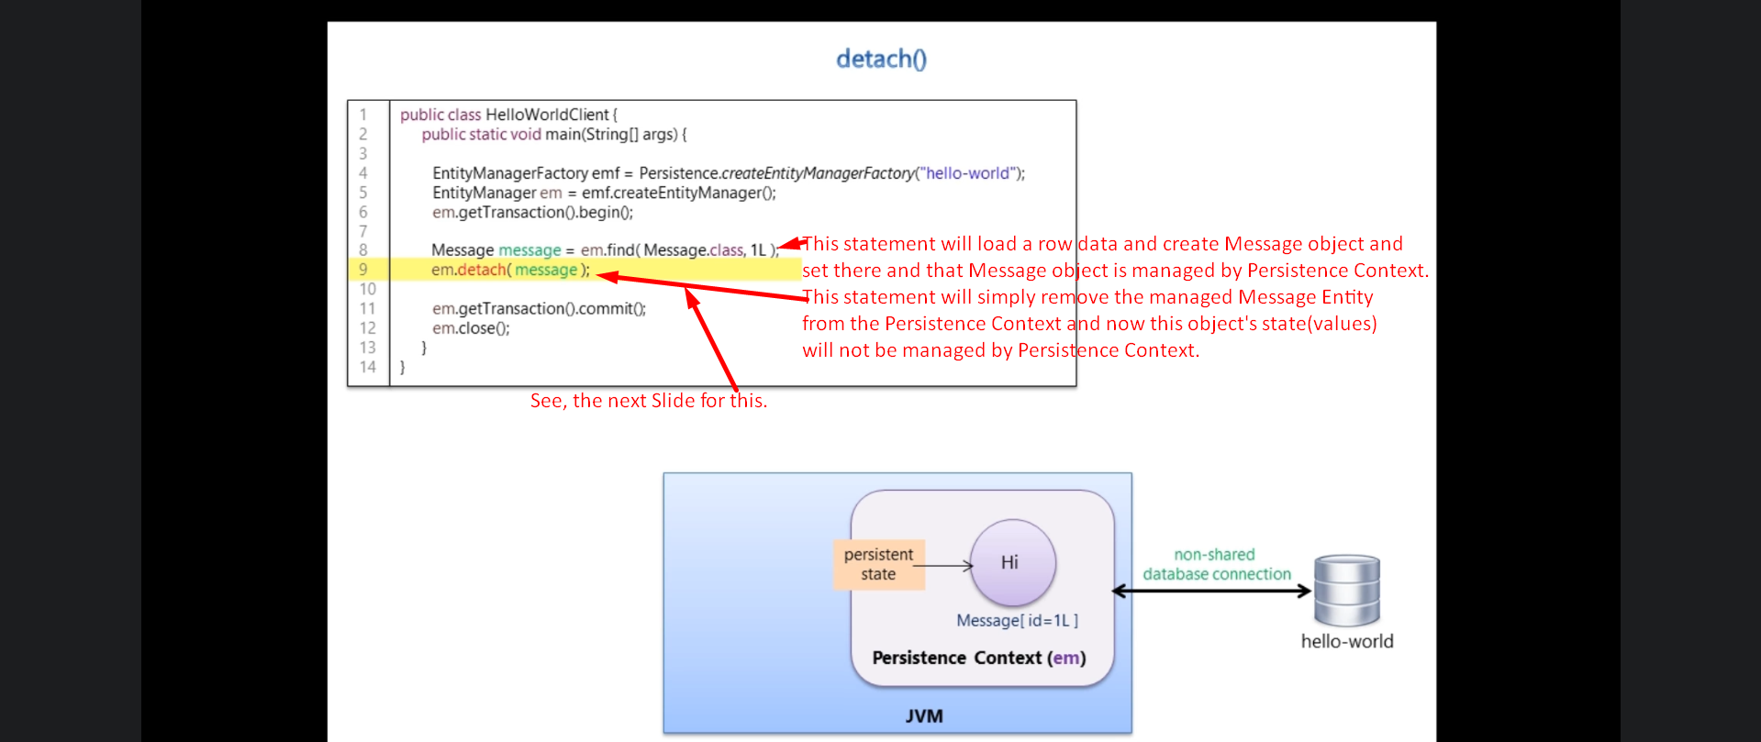
7. EntityManager.remove():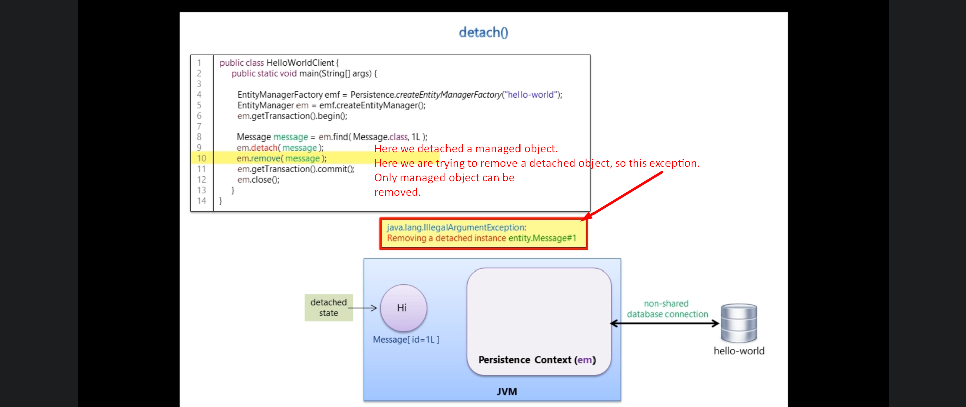
8. 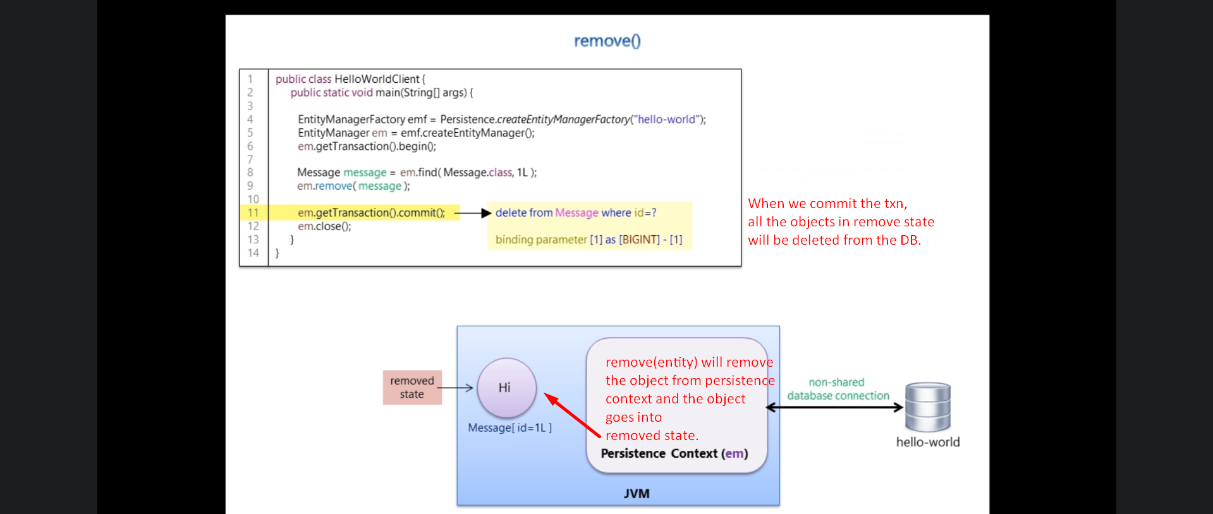
9. 